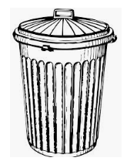
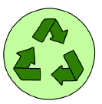
Recycle Sort

Need 2 paper plates: Put a green R (recycle) on one plate and an orange G (garbage) on another plate. Print off pictures and pictures and sort according to if they can be recycled or if they should be thrown away.

Alternative activity: Collect items at home throughout the day sort into two bags- color one bag green to recycle and the other will be the garbage bag. The bags can also be colored according to the colors of your own recycle and garbage pails that go out to the curb. This will make the activity relevant to real life.

