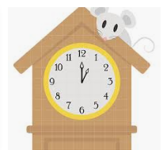
Hickory Dickory Dock

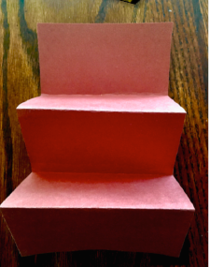
Supplies needed: large piece of construction paper 12 x18 or tape two pieces of computer paper together. Fold the paper in half lengthwise. Fold paper back and forth five times like an accordion.

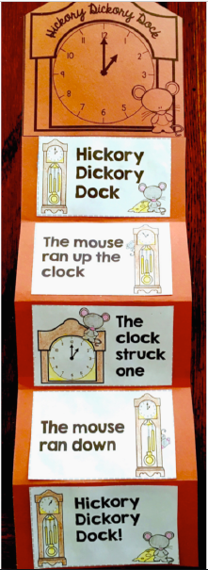
Glue the clock top to the top of the paper. Color the clock and the mouse in each picture. Next glue the rhyme in order. Finally, recite the fun nursery rhyme.

