Transportation Matching Game
Cut out the squares below to create a matching game. If you can see through the back of the cards glue each card to a piece of colored construction paper.
When playing the game encourage taking turns and using the names of each vehicle.
Have fun!

 | 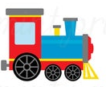
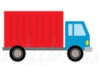
 | 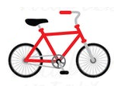
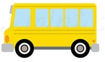 |  | 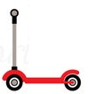
 | 