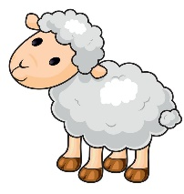
Writing Prompt – Little Bo Peep
Discuss the nursery rhyme Little Bo Peep.
Ask your child “Where do you think Bo Peep’s sheep went?”
Write down their answer to finish the writing prompt.
Ask your child to draw Bo Peeps sheep and where they might find them.
Encourage them to use the appropriate colors for things like the sun, grass, sky etc.

I think Little Bo Peep’s sheep are…

