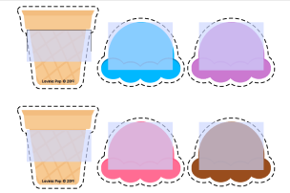
Build My Name

Directions: You will need a piece of computer paper or colored paper to build your name. Write your child’s name at the top of the paper. Next, count how many letters are in your child’s name. That is how many scoops of ice cream you will need. Use one scoop of ice cream to represent each letter in your child’s name. Have your child copy your writing one letter at a time and one scoop for each letter. Next build your ice cream name. Start at the top of the paper with the first letter (scoop) and place subsequent letters under each scoop. Last put the cone under the last letter of their name.
