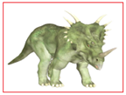
Dinosaur Memory

Print the card below to play memory. First play the game cards faced up to get familiar with the pictures. Then place 4 sets if cards face down. Turn over 2 cards. If they do not match turn them back over in the same spot they were found. Continue until matches are found. Increase the number of cards each time you play to increase the level of difficulty. Alternative activity use any stickers you have to create memory cards.

