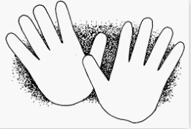
My Touch Investigation
If the object cannot be glue cut the words from the chart and put the words next to the object and take a picture of the final project. Have fun and be creative.
Find objects around the house that represents these sensory modes. Glue them in the space next to the word.
Smooth
Rough
Soft
Squishy
Bumpy

