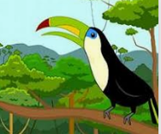
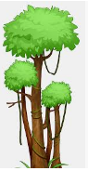
Complete the Pattern

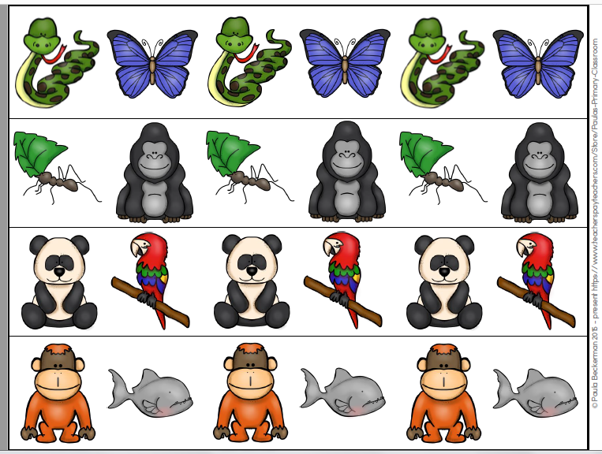
Have your child name each picture and tell what animal would come next in the pattern. (ABAB)

Have your child name each picture and tell what animal would come next in the pattern (ABB ABB)

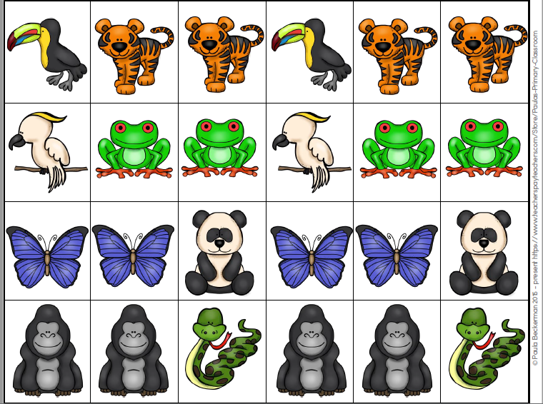
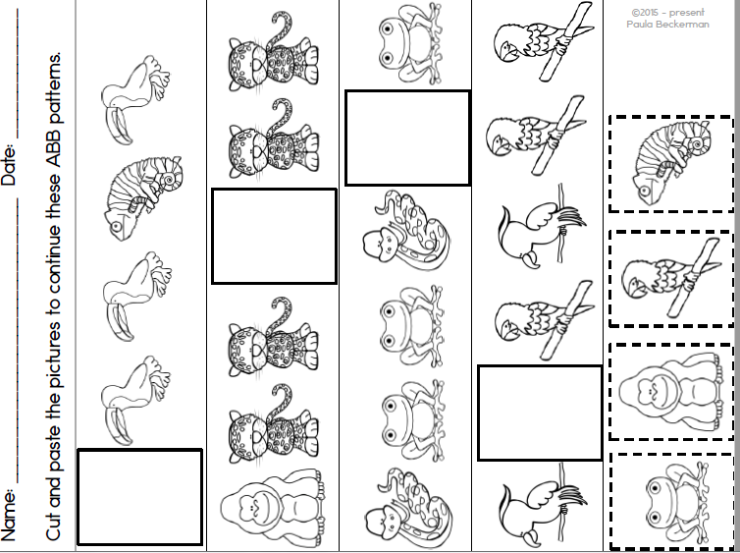
Cut and paste the pictures that would complete the pattern-then color.

