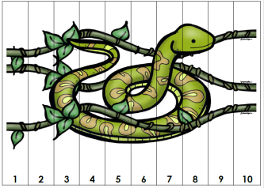
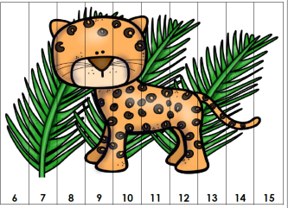
Rainforest Puzzles
The following number puzzles will help to reinforce number identification as well as ordering numbers. There are various skill levels below. No printer no problem. Take a picture from a coloring book and color it. Then cut it into strips. Put the numbers on the strips and have your child put the puzzle back together identifying and ordering the numbers correctly.

