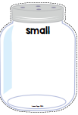
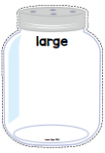

Small● Medium ●Large
Print off the three jars or draw 3 jars one small, one medium and one large or use 3 different size bags or bowls to collect items. Have your child collect 4 small things to go into the small jar or bag, 4 things to go into the medium jar or bag and 4 things to go into the large jar or bag. Encourage the vocabulary of small, medium and large. Have them compare the size of objects against each other. Choose 2 objects-Which one is smaller? Choose another 2 objects-Which one is larger? Finally put the objects in a long row from smallest to largest.
