Sorting Easter Eggs
Cut out Easter eggs below.
Encourage your child to sort them by color.
Then encourage your child to sort them by size (small, medium and large.)
Glue the eggs on the graph in the corresponding column.
Discuss which column has more eggs. Which column has the least amount of eggs?
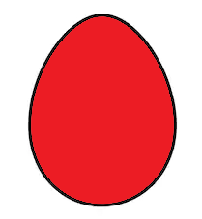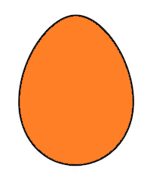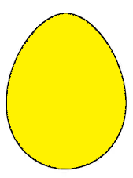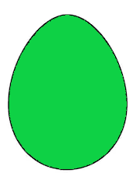

Small | Medium | Large

