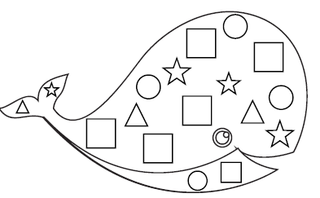
Whale Shape Graph

Directions: Have your child write their name. Identify the names of the shapes. Start with the square shape and color all squares blue. Then go to the triangle and color all triangles orange. Continue the same way for the circle and the star. Finally count the number of each individual shape.
