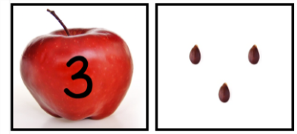
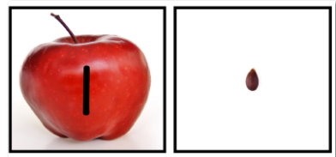
Apple Math Activity

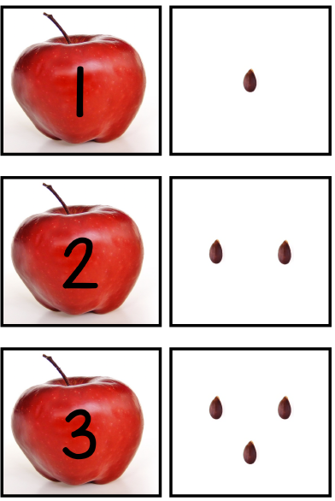
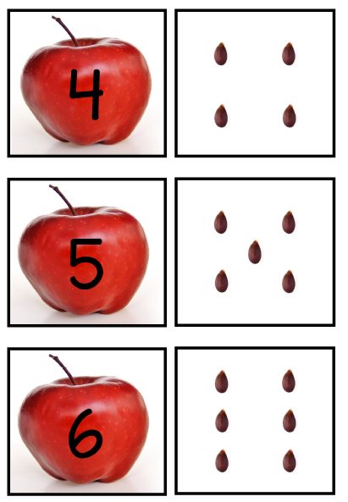
Print off apple cards with seeds. Have your child identify the number and then count the corresponding seeds. Then cut the cards in half to make two piles. One pile of apples and one pile of seeds. Start with numbers 1-5- have your child match the seeds to the apples. Add more cards as your child masters the numbers. ●To add another layer of tactile (kinesthetic) experience have your child count out objects such as pom, poms, Legos, elbow macaroni to reinforce skills.

