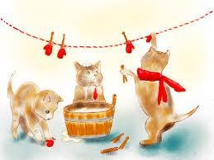
Writing Prompt – Three Little Kittens Lost their Mittens
Discuss the nursery rhyme The Three Little Kittens Who Lost their Mittens.
Ask your child “Where do you think the kittens found their mittens?”
Write down their answer to finish the writing prompt.
Ask your child to draw the kittens finding their mittens.
Encourage them to use the appropriate colors for things like the sun, grass, sky etc.

I think the three little kittens found there mittens…

