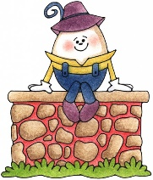
Writing Prompt – Humpty Dumpty
Discuss the nursery rhyme Humpty Dumpty.
Ask your child “How would you fix Humpty Dumpty?”
Write down their answer to finish the writing prompt.
Ask your child to draw themselves helping Humpty Dumpty.
Encourage them to use the appropriate colors for things like the sun, grass, sky etc.

I can fix Humpty Dumpty by…

