Recycle Garden
What you will need:
Paint
White paper
Recycled or reused items to create flowers

What to do:
Find items in your home you can reuse to create flowers. For example old corks held together with a rubber band. 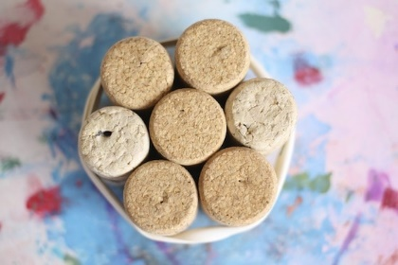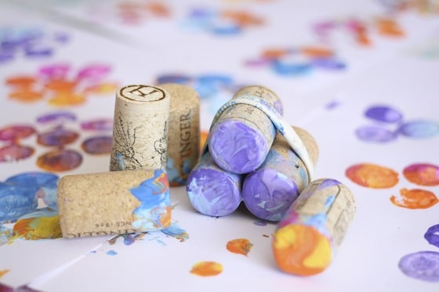
The bottom of a soda or water bottle. 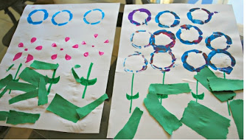
Cut a paper towel or toilet paper tube to create a flower shape.
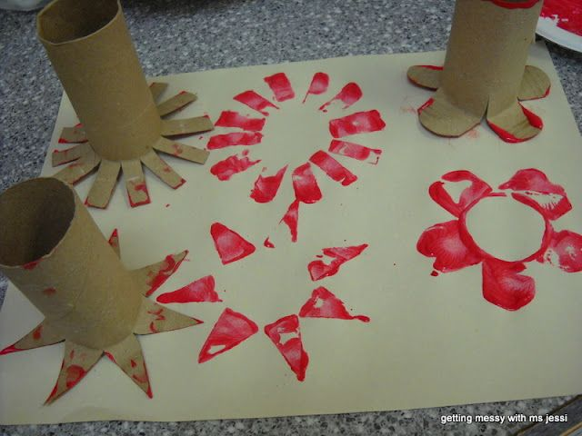
Any idea is a good idea!
Have fun creating your beautiful recycled garden!

