Marbled Shaving Cream Earth
What you will need:
Shaving cream
Blue and green paint or food coloring
Popsicle stick or plastic spoon or knife
Circular piece of paper or paper plate
Cookie sheet
What to do:
Cover a portion of the cookie sheet with shaving cream (larger than the area of your circle)
Have you child put dots of blue and green paint or food coloring on the shaving cream.
Allow your child to mix shaving cream with a popsicle stick or plastic utensil.
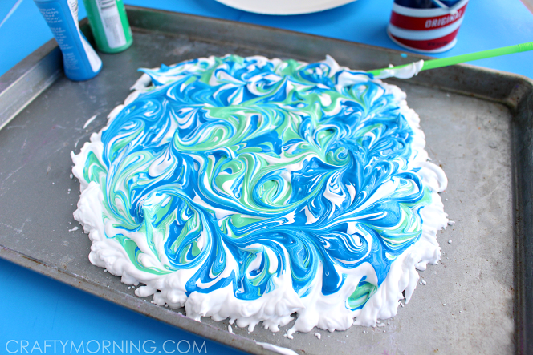
When they are all done press the blank circular piece of paper onto the shaving cream. Lift off and set aside.
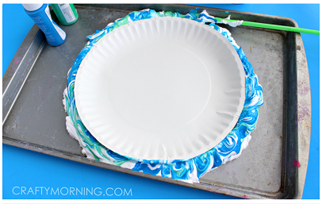
Turn the popsicle stick on its side and drag across the paper to remove excess shaving cream. Let dry.
