Tiger Art Project
What you will need:
Black and orange paint
Shaving cream
Piece of white paper
Cookie sheet
What to do:
Cut out the tiger and trace onto piece of white construction paper.
Cover the cookie sheet with shaving cream (a little bit larger then the tiger cut out)
Add stripes of orange and black paint to the shaving cream.
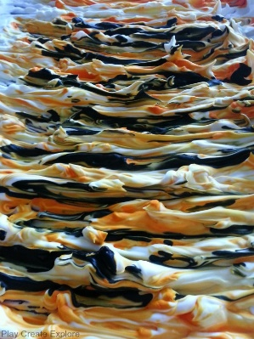
Take the popsicle stick and swirl the colors together a bit.
Take the cut out tiger shape and lay it flat on top of the striped shaving cream. Press down gently making sure to get all parts of the tiger.
Use the side of the popsicle stick to scrape off excess shaving cream.
Once the tiger has dried you can add eyes and a nose.
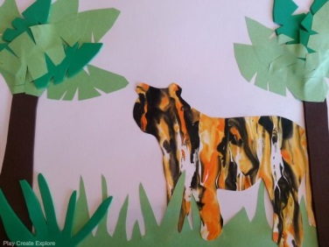
You can also add a background if you chose to.

