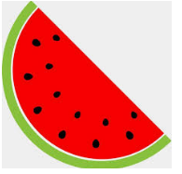
Watermelon Art Project

Watermelon facts: a watermelon is both a fruit and a vegetable- it is made up mostly of water- it grows on a vine- the flower on the vine is where the actual watermelon will grow from

What you will need:
Half of a paper plate
Red, green and black paint
A permanent marker green or red (for adult use only)
A sponge or paint brush
What to do:
Cut your paper plate in half.
With a permanent marker (regular markers will bleed when paint is applied) draw a half circle where the paper plate has an indent.
Explain that above the line they will paint red and below the line will be green.
If using a sponge to paint encourage them to use a bouncing movement to get into all the curvy parts of the plate. Be sure to get all the “peek-a-boo spots!”
Once they are done painting the red and green give them a small amount of black paint and to use one finger to make some seeds inside the red part of the watermelon.
