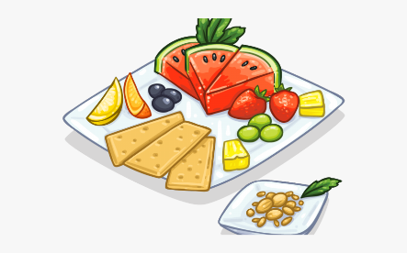
Writing Prompt – Healthy Snacks

Discuss: Healthy foods, grains, protein, vegetables, fruit and dairy.
Ask your child “What are your favorite healthy snacks?”
Write down their answer to finish the writing prompt.
Ask your child to draw themselves eating their healthy choices.
Encourage your child to use appropriate colors for things.

My favorite healthy snack is…

