Writing Prompt – How do Dinosaurs say goodnight?
Listen to the read aloud book Mrs. Albert posted called How do Dinosaurs say Goodnight.
Discuss: Your bedtime routines and using good bedtime manners.
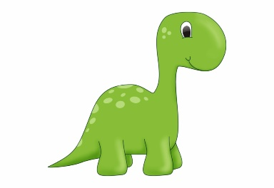
Ask your child “If you were a dinosaur how would you say goodnight?”
Encourage your child to use full sentences when answering.
Write down their answer to finish the writing prompt.
Ask your child to draw themselves as a dinosaur.
Encourage them to use the appropriate colors for things like the sun, grass, sky etc.

If I was a dinosaur I would say goodnight by…

