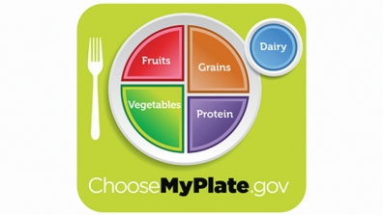
Writing Prompt -Make Your Own Lunch

Discuss: Healthy foods, grains, protein, vegetables, fruit and dairy.
Ask your child “If you could pack your own lunch what would you bring?”
Write down their answer to finish the writing prompt.
Ask your child to draw their healthy lunch choices.
Encourage your child to include at least one food from each food group.

If I could pack my own lunch I would bring…

