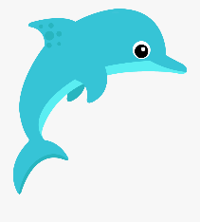
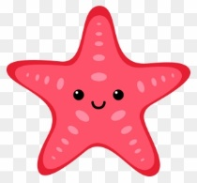
Writing Prompt -Ocean Animal
Discuss: What kinds of animals live in the ocean.
Ask your child “If you were an ocean animal what would you want to be? Why?”
Write down their answer to finish the writing prompt.
Ask your child to draw themselves as an ocean animal.
Encourage them to use the appropriate colors for things like the sun, grass, sky etc.

If I were an ocean animals I would be a______________
Because____________________________________________.

