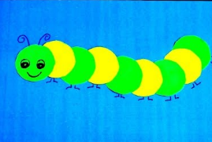
Caterpillar Patterns
Below you will find 6 circles. Have your child color or paint 3 circles one color and the other 3 a different color.
Help your child to use their scissor skills and cut out each circle.
Have them assemble their caterpillars in an AB pattern.
Glue the caterpillar to another sheet of colored paper.
Have your child give the caterpillar a face, legs and antenna. Encourage them to draw a background for the caterpillar, green grass, a yellow sun, flowers, etc.
Ask questions about your child’s caterpillar. What would you name him or her? What is their favorite thing to do? What does he eat?

