Week of | April 20-24  Theme- Earth Day-Recycle | April 27-May 1  Theme-Nursery Rhymes
Language  Arts | Students will learn about Earth Day and how to reduce-reuse and recycle things around the house. Students will respond to the writing prompt: “I can keep the earth clean by… Students will learn recycling songs | Students will learn nursery rhymes-rhyming words and sequencing-first-next-then Students will respond to the writing prompts: “How would you fix Humpty Dumpty?” “Where do you think the kittens found their mittens?”
Math | Students will use one to one correspondence to identify and count objects 1-20  Students will identify and order numbers 1-10 to create a number puzzle. | Students will identify and complete the pattern  Students will sequence the rhyme
Science | Students will identify and sort objects into two categories  recycle or garbage  Students will chart how often then do things around the house  that help the planet | Magic Milk experiment  See Science Button for Monday April 27 Dish soap + milk + food coloring cause a reaction
Motor Development | Daily outside time: Gym Day-Friday Hidden Treasure-Hide small toys or objects inside or outside. Then have your child race to find the objects- prize for finding all objects may be a special snack or more outside free play time | Gym Day-Friday Fill the bucket game: Ge 2 containers-place them a distance apart- get small objects to transfer from one bucket to the next- use a large or smaller spoon Daily outside time-weather permitting
Religion | Students will make a new life banner! Alleluia! | Seeds: How do we recognize Jesus-“In the good deeds we do for others and others do for us” Talk about what a good deed is.. It gives you a warm fuzzy
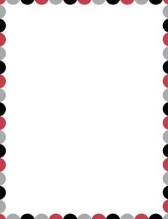
Pre-K 3 Curriculum Outline

