Week of | May 18-22  Theme: Dinosaurs | May 25-29  Theme: Nutrition | June 1-5  Theme: Ocean | June 8-11  Theme: Summer
Language  Arts | Students will identify and match upper and lower case letters Students will practice spelling their name using one to one letter correspondence | Students will learn about eating healthy fruits and vegetables.  Students will continue practicing writing and spelling their name & identifying and matching upper and lower case letters | Students will learn about ocean animal  Students will continue practicing writing and spelling their name & identifying and matching upper and lower case letters | Students will continue practicing writing and spelling their name & identifying and matching upper and lower case letters
Math | Students will find-sort & compare objects using the vocabulary small-medium-large | Students will identify order and use one to one correspondence to count and match objects to numbers | Students will identify order and use one to one correspondence to count and match objects to numbers | Students will identify order and use one to one correspondence to count and match objects to numbers
Science | Students will make an invisible drawing with lemon juice and water | Students will explore various textures such as rough, smooth, bumpy and squishy | Students will make an aluminum foil boat- add pennies- then drop a small ball from different heights what makes it sink?  https://www.youtube.com/watch?v=pK-iPwtW4W8 | Students will make ice cream in a bag! Enjoy!  https://www.youtube.com/watch?v=N4ztYjFxwmI
Motor Development | Daily outdoor recess  Jump Up Bend Down-Learning Station  https://www.youtube.com/watch?v=X7jSWdnoshw | Daily outdoor recess  Welcome to My Gym-exercise https://www.youtube.com/watch?v=ju8W_SX_wy4 | Daily outdoor recess  Kids workout 1 beginners  https://www.youtube.com/watch?v=L_A_HjHZxfI | Daily outdoor recess  Chicka Boom Summer Dance  https://www.youtube.com/watch?v=hfZ-438DrIs
Religion | Students will practice using their manners- “please & thank you”  “excuse me & you are welcome”  https://www.youtube.com/watch?v=qSnAVyqYT6c | Students will practice listening skills https://www.youtube.com/watch?v=zH82yqUWEi4 | Students will make kindness rocks https://www.youtube.com/watch?v=KIRv6Cyev2k | Let’s Choose Love  https://www.youtube.com/watch?v=xTAh8NhUdR8
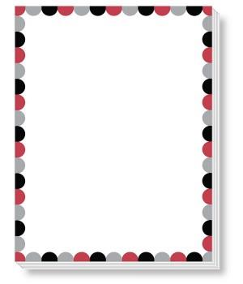
Pre-K 3 Curriculum Outline

