Week of | May 18-22  Theme: Dinosaurs
Language  Arts | Students will identify and match upper and lower case letters Students will practice spelling their name using one to one letter correspondence
Math | Students will find-sort & compare objects using the vocabulary small-medium-large
Science | Students will make an invisible drawing with lemon juice and water
Motor Development | Daily outdoor recess  Jump Up Bend Down-Learning Station  https://www.youtube.com/watch?v=X7jSWdnoshw
Religion | Students will practice using their manners- “please & thank you”  “excuse me & you are welcome”  https://www.youtube.com/watch?v=qSnAVyqYT6c
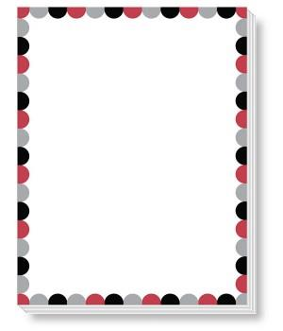
Pre-K 3 Curriculum Outline

