Week of | May 18-22  Theme: Dinosaurs | May 25-29  Nutrition
Language  Arts | Students will identify and match upper and lower case letters Students will practice spelling their name using one to one letter correspondence | Students will learn about eating healthy fruits and vegetables.  Students will continue practicing writing and spelling their name & identifying and matching upper and lower case letters
Math | Students will find-sort & compare objects using the vocabulary small-medium-large | Students will identify order and use one to one correspondence to count and match objects to numbers
Science | Students will make an invisible drawing with lemon juice and water | Students will explore various textures such as rough, smooth, bumpy and squishy
Motor Development | Daily outdoor recess  Jump Up Bend Down-Learning Station  https://www.youtube.com/watch?v=X7jSWdnoshw | Daily outdoor recess  Welcome to My Gym-exercise https://www.youtube.com/watch?v=ju8W_SX_wy4
Religion | Students will practice using their manners- “please & thank you”  “excuse me & you are welcome”  https://www.youtube.com/watch?v=qSnAVyqYT6c | Students will practice listening skills https://www.youtube.com/watch?v=zH82yqUWEi4
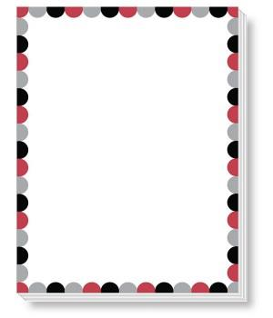
Pre-K 3 Curriculum Outline

