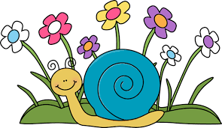

Writing Prompt – Caring for God’s Creations
Discuss what God’s creations are how we can work to take care of the plants and animals around us. Listen to the story of the day for some ideas.
Ask your child what they can do to care for God’s creations.
Write down their answer to finish the writing prompt below.
Ask your child to draw themselves doing the actions they described.
Encourage them to use the appropriate colors for things like the sun, grass, flowers etc.

I can care for God’s creations by…

