Helpful Tips for Distance Learning
Pre- K 3

● Check the school website and school emails for updated information

● Check the classroom website daily: Information is updated daily by 6:00pm

● Assignments are listed each day-click on the green rectangle buttons:
Read Aloud-Song-Art-Activity-Religion etc.

●No printer-no problem: All assignments can be adapted to supplies you may have at home. There are alternate suggestions in many of the assignments.

● Assignments are meant to be a resource to extend learning. Do what you can do and do not stress if everything is not completed. You are doing a great job.

● Check out the buttons for Mrs. Atkins (Library) Mrs. Connelly (School Counselor), Mr. Martin (Gym teacher). They are great resources for all!

● Email pictures of your child doing their distance learning and I will share them on my website

We are all in this together. Thank you for your patience as we all explore new avenues of learning.
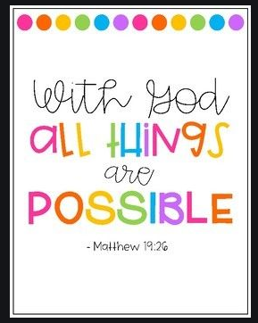
Mrs. Albert

