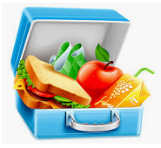If I could pack my own lunch-I would pack…

Alice- strawberries, eggs cheese stick pepperoni and pasta
Donny- pretzels, apples, oranges carrots, cheese
Julianne- apple, broccoli, carrots rice with cheese, egg, and celery juice
Ariah- I pack strawberries, blueberries, egg, carrots and pancakes
Rebekah-goldfish a sandwich, apple, and grapes
Riley- a peanut butter and jelly sandwich, banana, goldfish, apple and a chocolate
Annabelle- pineapple, beans
Gabriel- hummus, crackers, yogurt a spoon, banana and oranges
Mackenzie- crackers, turkey, broccoli, lettuce, blueberry and milk
Shea- chicken, pasta, carrots, strawberry and a cookie
Meadow- orange, broccoli, strawberry and a sandwich with cream cheese on it
Nailah-fish, pancake, egg

