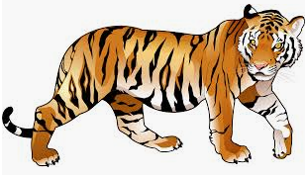
My tiger likes to eat…

Mary Kate- asparagus
Ariah- meat
Matthew- carrots
Riley- deer
Julianne- broccoli and carrots
Mackenzie- lettuce
Rosa- no vegetables- He eats buffalo deer and meat.
Rebekah- ham, cheese, chicken nuggets, mashed potatoes and peas
Meadow- broccoli
Gabriel- carrots
Annabella – corn
Nailah- carrots
Shea- red peppers and carrots
Alice- garlic broccoli

