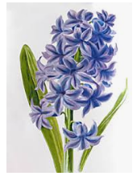
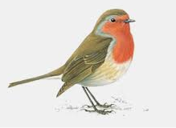
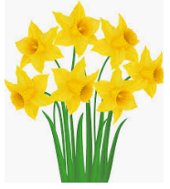
Signs of Spring
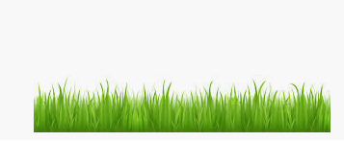
Shea- blue sky, flowers, sun and a bunny
Alice- I see all of this-this is the sun, this is the sky and these are the flowers
Meadow- grass, flowers and butterflies
Rebekah- I saw a butterfly guy and a mosquito got on my face and it was yucky!
Nailah- I saw a bird in a tree and some flowers
Riley- I saw flowers a sun and grass
Julianne- flowers, the sun and some rain drops
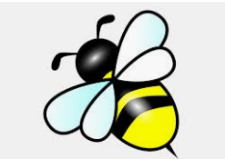
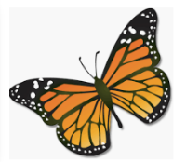
Ariah- flowers and birds
Rosa- butterflies
Yeva- butterlies
Mackenzie- flowers, bumblebees, butterflies and lady bugs
Annabelle- I saw grass and flowers and bees and rain and the sun
Donny- bees and butterflies
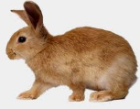
Matthew- I got flowers
Mary Kate- flowers, grass and bunnies

