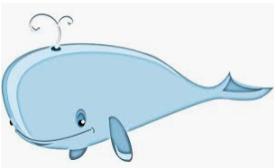
If I could be an ocean animal I would be…

Julianne: I want to be an octopus and swim when I wiggle.
Mackenzie: I want to be a turtle so I can hide in my shell.
Meadow: If I was a whale I could spit water out of my head and get people wet.
Annabelle: I want to be a dolphin because they splash in the water.
Ariah: I want to be a starfish and help people.
Rebekah: I would be a dolphin because they swim under the water.
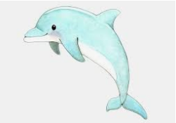
Riley: I would be a dolphin because they dive in the water and make a big splash.
Rosa: baby dolphin because I love them
Matthew: I would be a shark.
Gabriel: A jellyfish because I could sting people and protect myself.
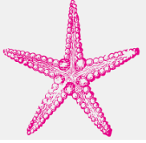
Shea: I would be a dolphin because they are friendly and they jump high.
