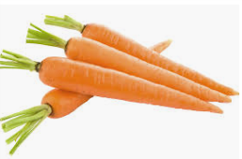
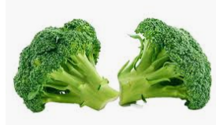
My favorite vegetable is…

Mackenzie- lettuce
Annabelle- lettuce
Ariah- carrots
Rebekah- I like carrots.
Nailah-carrots
Matthew- the bottoms of broccoli with no green parts
Gabriel- carrots dipped in hummus
Yeva- carrots
Rosa- carrots
Shea- carrots
Julianne- I like celery juice.

