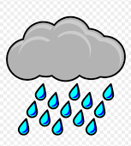
Writing Prompt - Weather
Discuss the different kinds of weather with your child and the fun things they like to do in each.
Ask your child what his or her favorite kind of weather is and why.
Write down their answer to finish the writing prompt.
Ask your child to draw the weather they said they liked the best in the rectangle below.
Encourage them to use the appropriate colors for each kind of weather.

My favorite kind of weather is…

