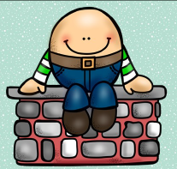
Directions: First sing the nursery rhyme. Next, cut apart the sequence cards, then mix up the cards, finally place the cards in correct order of the nursery rhyme and glue them into the sequence chart. Glue the chart on a piece of paper.

