 |  |  |  |  | 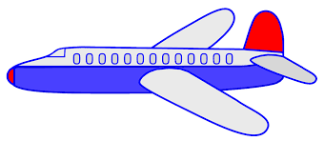
1 | 2 | 3 | 4 | 5 | 6 | 7 | 8 | 9 | 10
Transportation Counting Puzzles
Cut each puzzle into 10 pieces. Each piece should have part of the picture on it and the number on the bottom.
Have you child put each puzzles together, using the numbers to assist.
1 | 2 | 3 | 4 | 5 | 6 | 7 | 8 | 9 | 10
 |  |  |  |  | 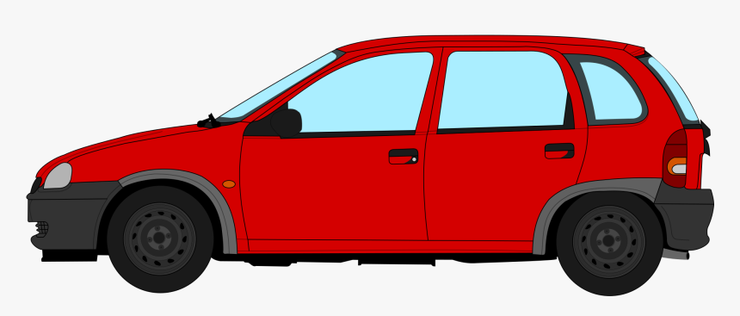
1 | 2 | 3 | 4 | 5 | 6 | 7 | 8 | 9 | 10

 |  |  |  | 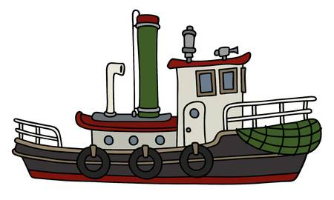
1 | 2 | 3 | 4 | 5 | 6 | 7 | 8 | 9 | 10
 |  |  |  |  | 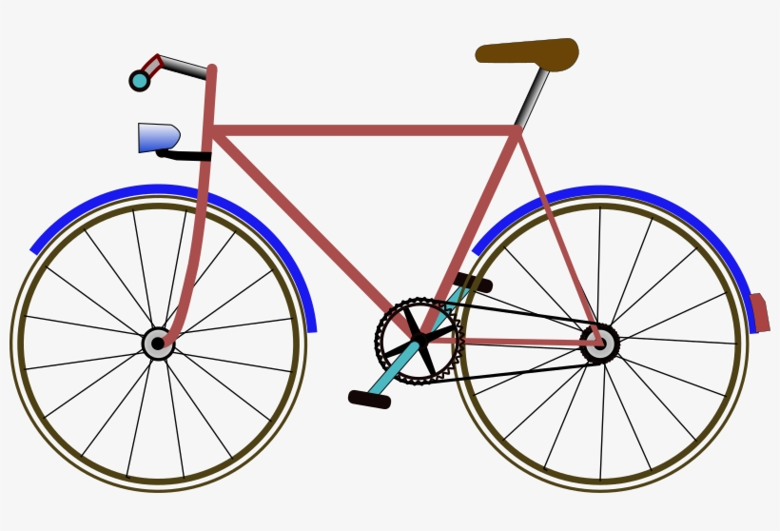
1 | 2 | 3 | 4 | 5 | 6 | 7 | 8 | 9 | 10
 |  |  |  | 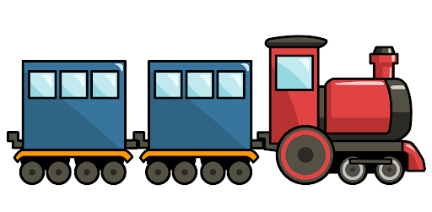
1 | 2 | 3 | 4 | 5 | 6 | 7 | 8 | 9 | 10

