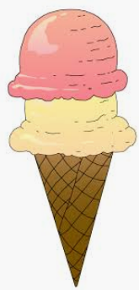
Ice Cream Numbers

Cut out the scoops of ice cream and cones. Match the dots on the ice cream scoops to the number on the cone. No printer no problem. Make your own scoops and cones from colored paper or white paper. Have a yummy treat when you are done!

