Alphabet Matching
Recite the nursery rhyme. Then cut out upper and lower case letters. Start with letters A-D. Have your child name the letter and match upper and lower case letter. Add three more sets of upper and lower case as your child masters the previous letters. This activity is to reinforce letter identification and matching. Each child will progress at his/her own pace over time.
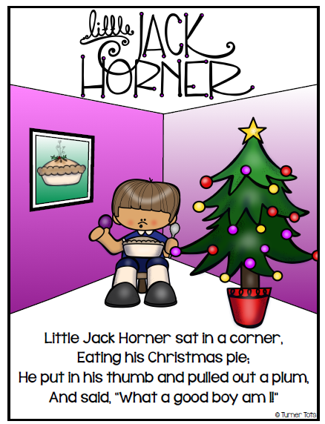

Below are color and black and white letter sheets.
