Transportation Clip-cards
First cut out each card. Each card has a picture of vehicles with 3 different numbers on the bottom.
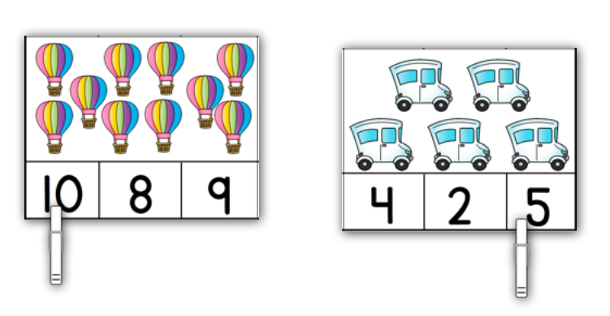
Have your child count the amount of vehicles and then clip a clothespin on the correct answer.
