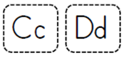
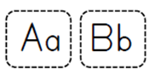
Color a Letter

These cards can be used in various ways. There are separate upper and lower case letter squares. Cut the squares apart then match upper and lower case letters. No printer-no problem: These letter cards can be made out of small squares of paper. Start matching A-D and increase letters as your child meets with success. Mastery means they can match letters correctly at least 4 out of 5 times. As your child masters each letter let them color the letter in yellow or orange. A highlighter will also work well.

