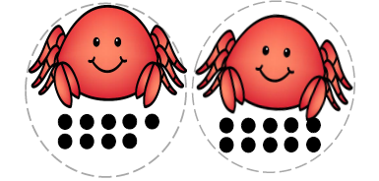
Counting Crabs

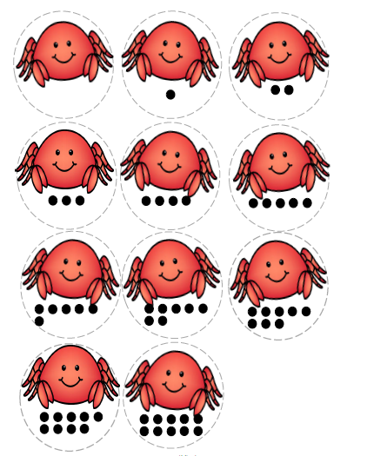
Directions: Cut out color or black and white crabs. Have your child identify each number on the crab bucket. Then have your child identify each crab with dots by number and match it to the number on the crab bucket. Glue the correct crab to the corresponding number on the bucket. Finally color the bucket.

