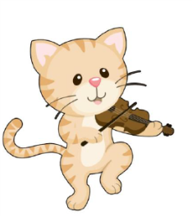
Hey Diddle Diddle

Recite the nursery rhyme and finish the pattern below. Cut the strip at the bottom and glue the correct picture to complete the pattern. No printer no problem: do the activity orally.
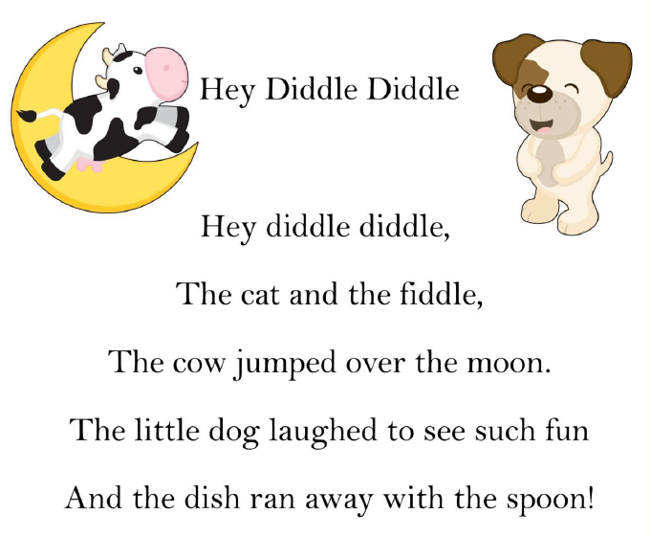

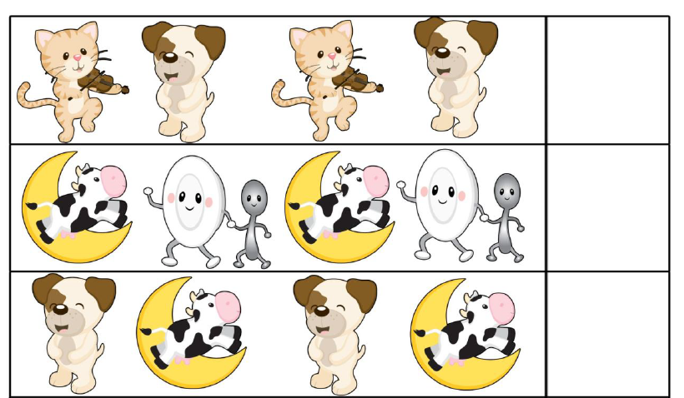

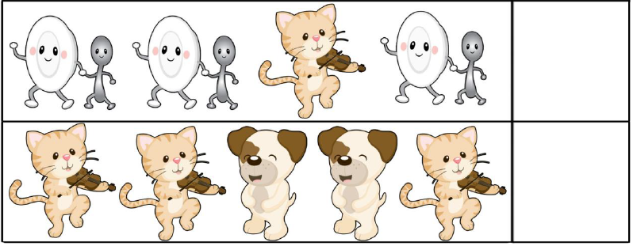

---------------------------------------------------------------------------------------------------- Cut and glue the picture to complete the pattern.
