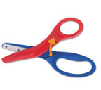
Scissor Practice

The link below will help guide proper scissor hand position and cutting.
https://www.youtube.com/watch?v=TT3PCQTBdeM

Use the templates below to practice cutting skills. No printer no problem. Make lines on a piece of paper and guide your child to hold the scissor correctly (open-shut-open-shut).
