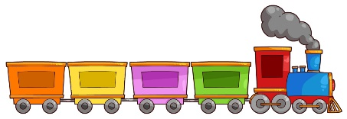
Writing Prompt – Planes, Trains or automobiles
Discuss the different modes of transportation with your child. Planes, trains, cars, bikes, boats, helicopters, scooters and any others you can think of.
Ask your child what their favorite mode of transportation is and why?
Write down their answer to finish the writing prompt.
Ask your child to draw themselves with their favorite transportation.
Encourage them to use the appropriate colors for things like the sun, grass, sky etc.

My favorite kind of transportation is…

