Handprint Stegosaurus
What you will need:
Paint
Glue
Googly eye
Colored paper (or have your child color the outline)
What to do:
Cut out the dinosaur shape onto colored paper or have your child paint or color it.
Have your child glue the dinosaur to the lower portion of a sheet of paper. (Make sure to leave room for handprints!)
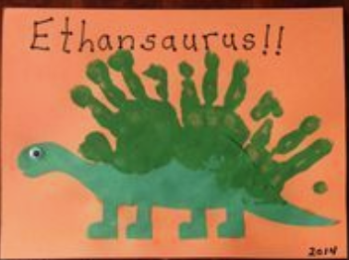
Paint your child’s hand and stamp it on the dinosaurs back to create the stegosaurus’ spikes. (I suggest keeping some wipes nearby!) If you do not wish to paint your child’s hand you can trace their hand and them out instead.
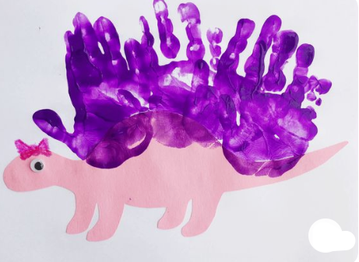
Add a googly eye and mouth.
