Rectangle Name Rockets!
Attached you will find 3 triangles and several rectangles for your child’s name rocket. Ask you child to identify each shape.
You can choose to use the shapes on this paper and paint or color them or you can use colorful paper. Whatever you have handy works.
Cut out the shapes.
Your rocket will be as long as your name- if you only have 4 letters you only need to cut out 4 rectangles.
Write one letter of your name on each shape.
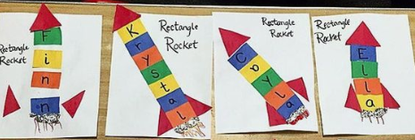
Assemble your rocket on by gluing the pieces onto another sheet of paper.

