Hickory Dickory Dock Clock
What you will need:
A paper plate
Scissors
Glue
Marker

What to do:
Have your child cut out the numbers 1 through 12.
Practice number recognition.
Place them on the paper plate in the correct position and allow your child to glue them on.
Add the clock hands. (if you do not have a brad to secure the hands to the clock glue them on instead)
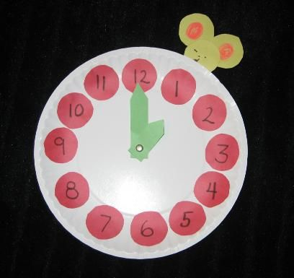
Have your child use the 3 blank circles to create a mouse. Have them draw a face on one and use the other 2 as ears. Attach the clock.
