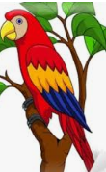
Parrot Art Project
What you will need:
Colorful paper
Glue and scissors
What to do:
Cut out the outline of the parrot and trace onto any colorful paper, then cut that out as well.
Trace the beak onto a different colored piece of paper and glue onto your colorful body.
Trace your child’s hand onto at least 5 different colored pieces of paper of their choice.
Glue them onto the parrot body to create feathers. Add an eye to your parrot.
Ask your child:
What would you name your parrot?
What is your parrot’s favorite thing to do?
Encourage them to answer in full sentences.
Record their answers and bring them to Mrs. Albert’s zoom meeting on Thursday.
